**THE CONTEST LIST**

**Printed On: 4/30/2025 1:16:49PM**

**Special Election 22 State Senate ‑ 05/20/2025**

**THE CONTEST LIST**

**Special Election 22 State Senate ‑ 05/20/2025**

**Kings All Parties and Independent Bodies**

**TENTATIVE**

**SUBJECT TO CHANGE**

**BOARD OF ELECTIONS**

**IN THE CITY OF NEW YORK**

**PRINTED AS OF:**

**4/30/2025 1:16:49PM**

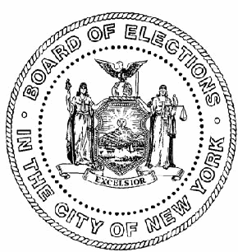Party/Independent Body

Name

Candidate #

Line #

Column

Address

**All Parties and Independent Bodies**

**Nominations for the following offices and positions:**

State Senator

Page 2 of 3

**THE CONTEST LIST**

**Special Election 22 State Senate ‑ 05/20/2025**

**Kings All Parties and Independent Bodies**

**TENTATIVE**

**SUBJECT TO CHANGE**

**BOARD OF ELECTIONS**

**IN THE CITY OF NEW YORK**

**PRINTED AS OF:**

**4/30/2025 1:16:49PM**

Party/Independent Body

Name

Candidate #

Line #

Column

Address

**State Senator ‑ 22nd Senatorial District, # to be elected: 1**

2036 East 5 Street Brooklyn, NY 11223

1

Sam Sutton

253986

Democratic

25

1547 57 Street Brooklyn, NY 11219

2

Nachman Caller

195577

Republican

25

1547 57 Street Brooklyn, NY 11219

3

Nachman Caller

195577

Conservative

25

Page 3 of 3